**Momentary Push Button Switch:**

It is the push button used to make or break circuit depending upon the purpose

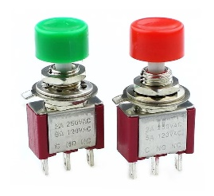 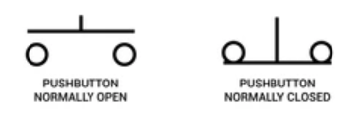

1. Normally Open Momentary Push Button Switch:

It requires continuous press to keep contact within the circuit and keep the device “on”

1. Normally Closed Momentary Push Button Switch:

It requires continuous press to break contact within the circuit and keep the device “off”

**Limit Switch:**

Limit switches are used to detect the presence or absence of an object

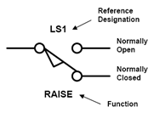 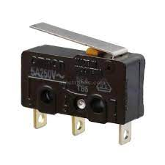

**Inductive and Capacitive Sensor:**

Inductive sensors uses the principle of electromagnetic induction to detect the proximity of metal targets to an inductive coil sensor.

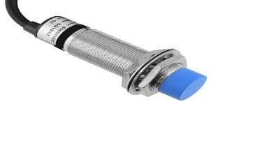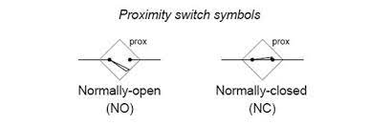

Capacitive sensors detect the change in capacitance between a sensor and electrode.

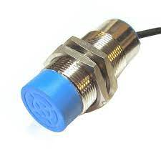

**Circuit Breaker:**

It is a device used for the protection of appliances from over current. The selection of circuit breaker is on the basis of current consumed by the load keeping additional 20% current

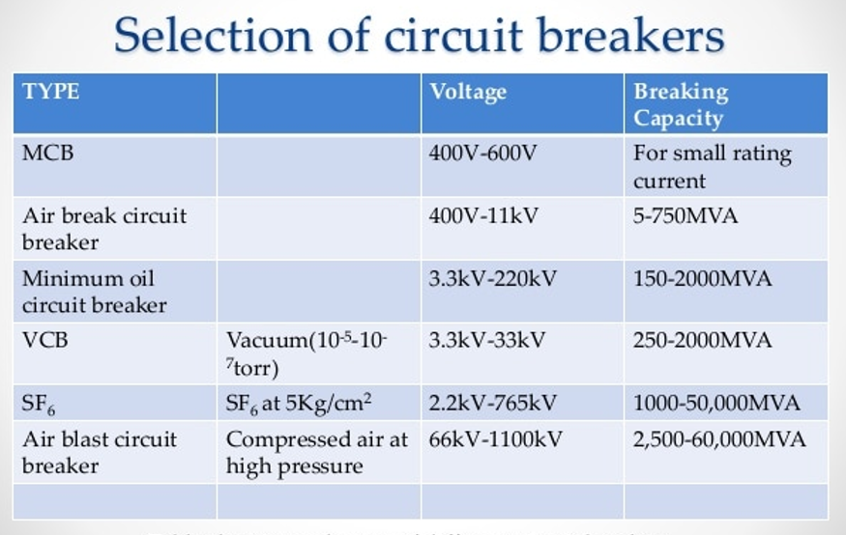

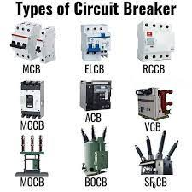

**Fuse:**

Fuse is also to protect appliances from over current and short circuit. The main difference between breaker and fuse is that it can be used for one time only as it is not repairable whereas breaker is repairable.

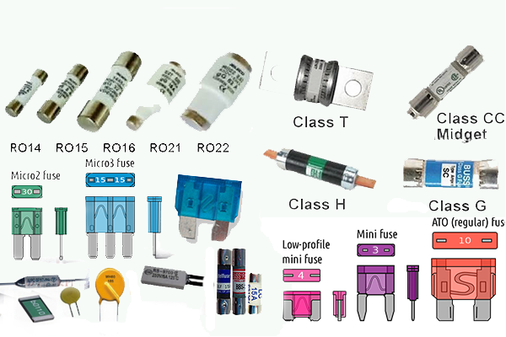

**Contactor:**

A contactor is an electrically controlled switch used for switching a power circuit, similar to a relay but with higher current ratings. It is mainly used for three phase system

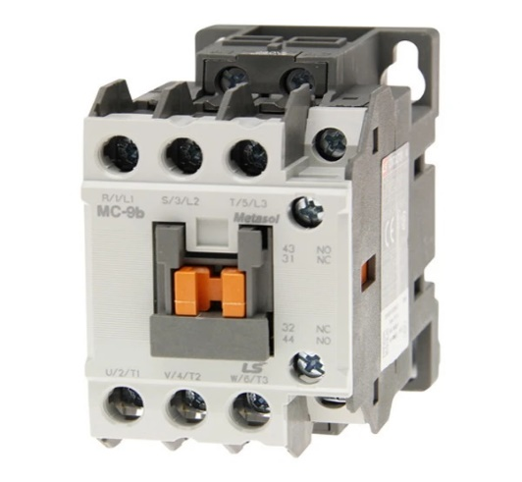 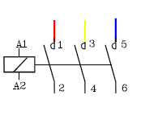

**Relay:**

A relay is an electrical switch. In industries, it is widely used for controlling with PLC and as protective relay. It is used with single phase and in low power applications

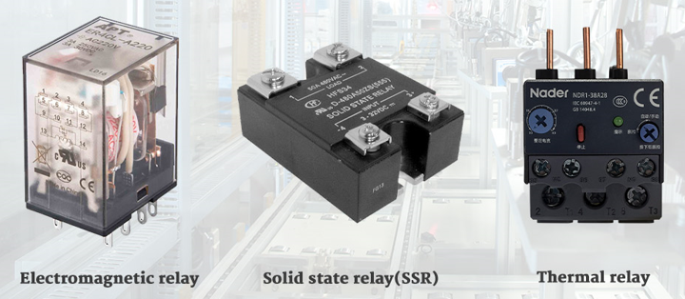 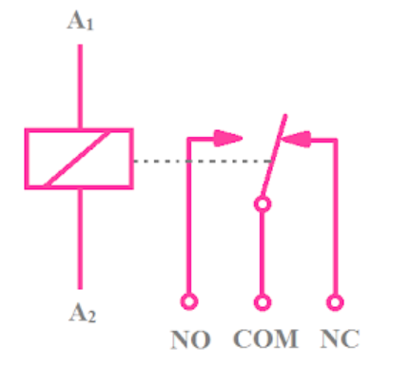

**Transformer:**

Transformers are used to **increase low AC voltages at high current** (a step-up transformer) or decreasing high AC voltages at low current (a step-down transformer).

